**DAILY ONLINE ACTIVITIES SUMMARY**

|  |  |  |  |  |  |  |  |  |
| --- | --- | --- | --- | --- | --- | --- | --- | --- |
| **Date:** | **12-06-2020** | | | | | **Name:** | **Anusha** | |
| **Sem & Sec** | **VIII Semester & A Section** | | | | | **USN:** | **4AL16CS014** | |
| **Online Test Summary** | | | | | | | | |
| **Subject** | | **BDA** | | | | | | |
| **Max. Marks** | | **30** | | **Score** | | | **23** | |
| **Certification Course Summary** | | | | | | | | |
| **Course** | **Webinor on Skill Development** | | | | | | | |
| **Certificate Provider** | | | **Brain O Vision** | | **Duration** | | | **3 hour** |
| **Coding Challenges** | | | | | | | | |
| **Problem Statement: Python Program to Remove Punctuations From a String** | | | | | | | | |
| **Status: COMPLETED** | | | | | | | | |
| **Uploaded the report in Github** | | | | | **YES** | | | |
| **If yes Repository name** | | | | | **anushasuvarna-014** | | | |
| **Uploaded the report in slack** | | | | | **YES** | | | |

Online Test Details:

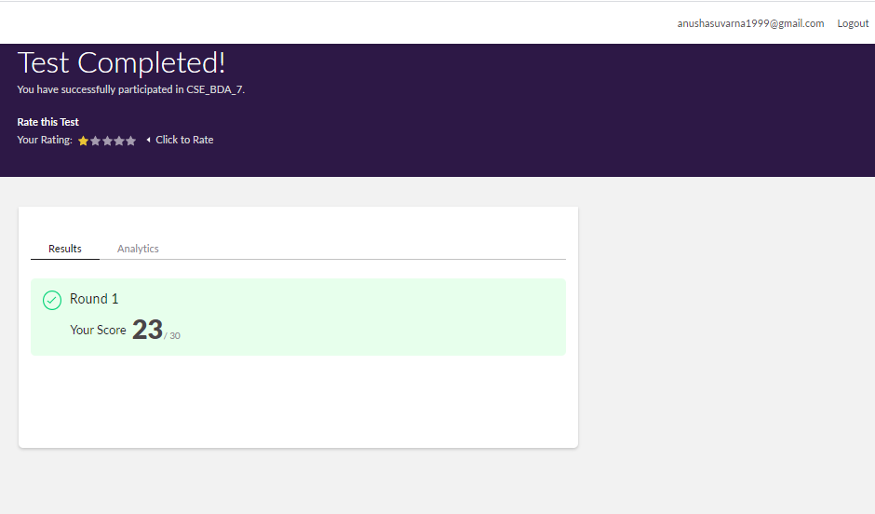Certification Course:

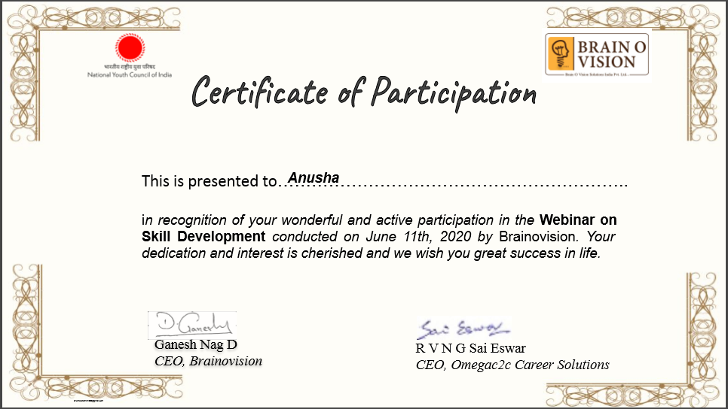

Coding Challenges Details:

**Program:**

# define punctuation

punctuations = '''!()-[]{};:'"\,<>./?@#$%^&*_~''' my_str = "Hello!!!, he said ---and went."

# To take input from the user

# my_str = input("Enter a string: ")

# remove punctuation from the string no_punct = ""

for char in my_str:

if char not in punctuations: no_punct = no_punct + char

# display the unpunctuated string print(no_punct)